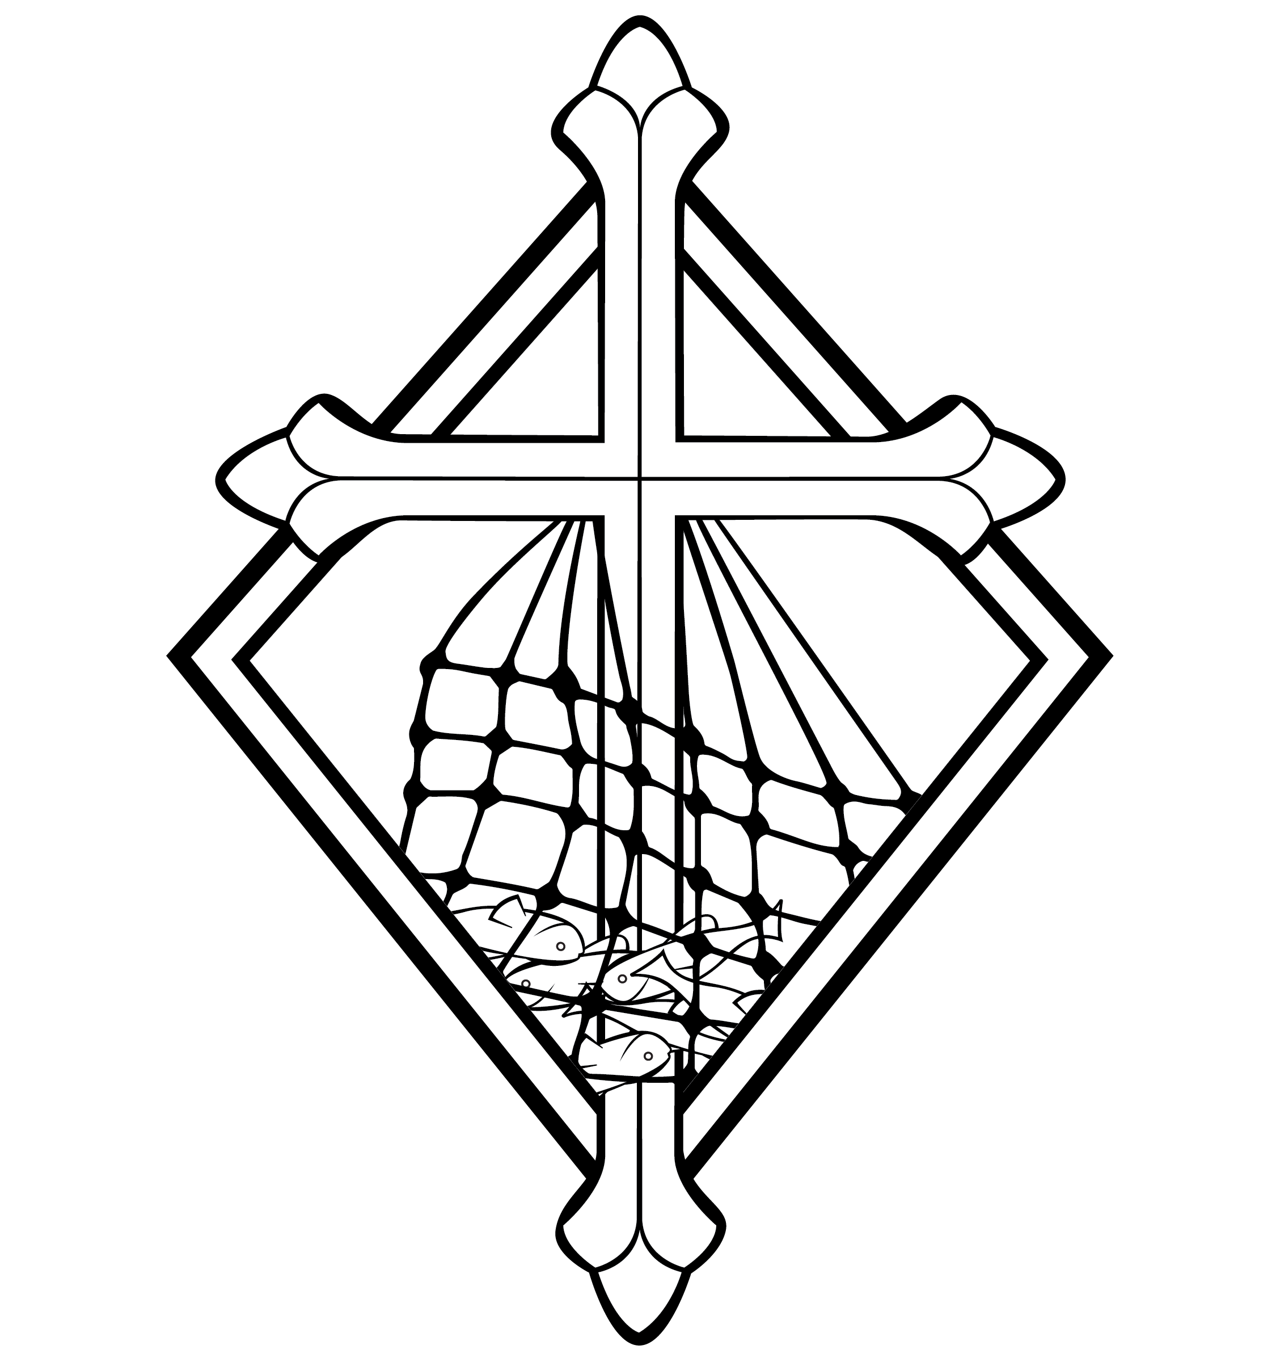
10th Sunday after Pentecost
CHRIST LUTHERAN CHURCH | Lodi, California
August 6, 2023

WELCOME TO WORSHIP
Welcome to Christ Lutheran Church. We pray that your soul will be strengthened by the good news about God’s grace, love, and forgiveness given to us. If you would like to learn more about our church, please speak with our pastor or one of our members after the service.
- Bathrooms are located in the fellowship hall. A changing table is located in the women’s bathroom.
WORSHIP THEME
How rich are we? We have the treasures of the gospel: the forgiveness of sins and eternal life in Christ. We have a heavenly Father who cares and provides for us richly and daily. We have the Holy Spirit who guides us and comforts us in all trouble. We are truly rich! But how easy it is for us to pursue the so-called riches of this world. May God strengthen us today to turn away from the things that perish and find our true wealth in Him.
The Common Service
The high and holy worship of God is faith in Jesus Christ. Such faith is created and sustained by God’s service to us (the German, “Gottesdienst,” “The Divine Service”). In the Divine Service, the Lord comes to us in His Word and Sacrament to bless and enliven us with His gifts. The Service is not something we do for God, but His service to us received in faith. The liturgy is God’s work. He gives, we receive.
HYMN To Your Temple I Draw Near | CW 226
INVOCATION
M: In the name of the Father, and of the Son ✙ and of the Holy Spirit
C: Amen.
CONFESSION
From God’s Word we know that wherever God puts His name, there He is to bless. In the Old Testament the temple was the place where God graciously caused His name to be present (1 Kings 8:27-30).
God has put His name —Father, Son, and Holy Spirit—on us in Holy Baptism. The Divine Service begins with the Invocation, the words spoken over us at our baptisms. Every Divine Service is for the hallowing of the Lord’s name, which the Small Catechism reminds us is done “when the Word of God is taught in its truth and purity, and we, as the children of God, also lead holy lives according to it” (Matthew 28:18-20).
M: Beloved in the Lord: let us draw near with a true heart and confess our sins to God our Father, asking him in the name of our Lord
Jesus Christ to grant us forgiveness.
C: Holy and merciful Father, I confess that I am by nature sinful, and that I have disobeyed you in my thoughts, words, and actions. I have done what is evil and failed to do what is good. For this I deserve your punishment both now and in eternity. But I am truly sorry for my sins, and trusting in my Savior
Jesus Christ, I pray: Lord, have mercy on me, a sinner.
Lord, have mercy on us. Christ, have mercy on us. Lord, have mercy on us.

absolution
M: God, our heavenly Father, has been merciful to us and has given
his only Son to be the atoning sacrifice for our sins. Therefore, as
a called servant of Christ and by his authority, I forgive you all
your sins in the name of the Father and of the Son ✙ and of the
Holy Spirit.
C: Amen
M: In the peace of forgiveness, let us praise the Lord.
C: Glory be to God on high,
and on earth peace, good will toward men.
We praise you, we bless you, we worship you,
We glorify you, we give thanks to you, for your great glory.
O Lord God, heavenly King, God the Father almighty.
O Lord, the only begotten Son, Jesus Christ;
O Lord God, Lamb of God, Son of the Father,
You take away the sin of the world; have mercy on us.
You take away the sin of the world; receive our prayer.
You sit at the right hand of God the Father; have mercy on us.
For you only are holy; you only are the Lord.
You only, O Christ, with the Holy Spirit,
Are most high in the glory of God the Father. Amen.
PRAYER OF THE DAY
M: The Lord be with you.
C: And also with you.
M: Let us pray.
O Lord, your ears are always open to the prayers of your humble servants, who come to you in Jesus’ name. Teach us always to ask according to your will that we may never fail to obtain the blessings you have promised; through Jesus Christ, your Son, our Lord, who lives and reigns with you and the Holy Spirit, one God, now and forever.
C: Amen
FIRST LESSON 1 Kings 3:5–12
Solomon already possessed great wisdom: to seek God’s help in his task as king and leader of God’s people showed humility and faith.
⁵ At Gibeon the Lord appeared to Solomon during the night in a dream, and God said, “Ask for whatever you want me to give you.”
⁶ Solomon answered, “You have shown great kindness to your servant, my father David, because he was faithful to you and righteous and upright in heart. You have continued this great kindness to him and have given him a son to sit on his throne this very day.
⁷ “Now, Lord my God, you have made your servant king in place of my father David. But I am only a little child and do not know how to carry out my duties. ⁸ Your servant is here among the people you have chosen, a great people, too numerous to count or number. ⁹ So give your servant a discerning heart to govern your people and to distinguish between right and wrong. For who is able to govern this great people of yours?”
¹⁰ The Lord was pleased that Solomon had asked for this. ¹¹ So God said to him, “Since you have asked for this and not for long life or wealth for yourself, nor have asked for the death of your enemies but for discernment in administering justice, ¹² I will do what you have asked. I will give you a wise and discerning heart, so that there will never have been anyone like you, nor will there ever be.
PSALM Psalm 119b, page 110
SECOND LESSON 1 Timothy 6:17–21
True wisdom does not put its hope in wealth but guards and keeps the treasure of the gospel. The preacher of the gospel reminds God’s people where their true treasure lies.
⁷ Command those who are rich in this present world not to be arrogant nor to put their hope in wealth, which is so uncertain, but to put their hope in God, who richly provides us with everything for our enjoyment. ¹⁸ Command them to do good, to be rich in good deeds, and to be generous and willing to share. ¹⁹ In this way they will lay up treasure for themselves as a firm foundation for the coming age, so that they may take hold of the life that is truly life.
²⁰ Timothy, guard what has been entrusted to your care. Turn away from godless chatter and the opposing ideas of what is falsely called knowledge, ²¹ which some have professed and in so doing have departed from the faith.
Grace be with you all.
VERSE OF THE DAY John 6:68
Alleluia. Lord, to whom shall we go? You have the words of eternal life. Alleluia.
THE GOSPEL Matthew 13:44–52
Jesus tells us three parables about the kingdom of God: there is great treasure to be found in Christ, and those who do not find him are eternally lost.

The Parables of the Hidden Treasure and the Pearl
⁴⁴ “The kingdom of heaven is like treasure hidden in a field. When a man found it, he hid it again, and then in his joy went and sold all he had and bought that field.
⁴⁵ “Again, the kingdom of heaven is like a merchant looking for fine pearls. ⁴⁶ When he found one of great value, he went away and sold everything he had and bought it.

The Parable of the Net
⁴⁷ “Once again, the kingdom of heaven is like a net that was let down into the lake and caught all kinds of fish. ⁴⁸ When it was full, the fishermen pulled it up on the shore. Then they sat down and collected the good fish in baskets, but threw the bad away. ⁴⁹ This is how it will be at the end of the age. The angels will come and separate the wicked from the righteous ⁵⁰ and throw them into the blazing furnace, where there will be weeping and gnashing of teeth.
⁵¹ “Have you understood all these things?” Jesus asked.
“Yes,” they replied.
⁵² He said to them, “Therefore every teacher of the law who has become a disciple in the kingdom of heaven is like the owner of a house who brings out of his storeroom new treasures as well as old.”

M This is the Gospel of the Lord.
C: Praise be to you, O Christ!
NICENE CREED
We believe in one God, Dt. 6:4
the Father, the Almighty, 2 Cor. 6:18
maker of heaven and earth, Is. 51:13
The Nicene Creed is the great Confession of the Christian faith professed by all Christians. The Creed originated at the First Council of Nicaea (c. AD. 325)
of all that is, seen and unseen. Col. 1:16
We believe in one Lord, Jesus Christ, 1 Cor 8:6
the only Son of God, Jn. 3:16
eternally begotten of the Father, Heb. 1:2,5
God from God, Light from Light, true God from true God, Jn. 1
begotten, not made, of one being with the Father. Jn. 10:30
Through him all things were made. Jn. 1:3
For us and for our salvation, 1 Th. 5:9
he came down from heaven, Jn. 6:38
was incarnate of the Holy Spirit and the virgin Mary, Lk. 1:35
The Creed itself was crafted as a confession of Scripture in opposition to the Arian heresy, which denied that the Lord Jesus and the Holy Spirit are God.

and became fully human. Gal. 4:4
For our sake he was crucified under Pontius Pilate. Mk. 15:15
He suffered death and was buried. 1 Cor. 15:3-4a
On the third day he rose again in accordance
with the Scriptures. 1 Cor. 15:4b
He ascended into heaven Ac. 2:33-34
and is seated at the right hand of the Father. Heb. 1:13
He will come again in glory Mt. 25:31
to judge the living and the dead, 2 Tim. 4:1
and his kingdom will have no end. Lk. 1:33
We believe in the Holy Spirit, the Lord, the giver of life, Job 33:4
who proceeds from the Father and the Son, Jn. 15:26
who in unity with the Father and the Son Jn. 4:24
is worshiped and glorified,
who has spoken through the prophets. 2 Pet. 1:25

We believe in one holy Christian and apostolic Church. Mt. 16:18; Eph. 2:19-20
and apostolic Church.
We acknowledge one baptism for the forgiveness of sins. Eph. 4:5; Ac. 2:38
We look for the resurrection of the dead 1 Cor. 15:21-22
and the life of the world to come. Amen. Rev. 22

HYMN OF THE DAY One Thing’s Needful| CW 290
SERMON Matthew 13

OFFERING
In response to God’s love and forgiveness, we give back a portion of what he has given us. The members of Christ Lutheran Church have joined to proclaim the gospel to this community. These offerings support that work. While our guests are welcome to participate, they should not feel obligated to do so.
PRAYER OF THE CHURCH
M: Eternal God and Father, we give you thanks for the blessings we share as members of your holy Church, for your Word and Sacraments, for opportunities to serve others, for fellowship with Christians in our congregation and throughout the world.
C: Help us always to rejoice in these blessings, dear Lord, and to use them faithfully.
M: Raise up for us honest, wise, courageous and just leaders. Protect those who protect our nation and our communities. Give us and all citizens a willingness to obey our nation’s laws and to work for the common good. Provide us with daily bread and preserve us from all calamity according to your grace.
C: Teach us not to worry, but to cast all our cares on you.
M: Jesus Christ, Lord of the Church, you give grace to your people by calling us to be your witnesses in the world. Open our eyes to see the noble mission you have placed before us. In the hurting eyes of the lonely, in the pained eyes of the sick, and in the searching eyes of the lost, help us to see your face, O Jesus, and to serve others as we would serve you.
C: Through our lives, make your light shine.

M: Holy Spirit, giver of life, through Word and Sacrament bestow on us the wisdom and power we need to witness clearly and to act boldly. Help us to speak the truth in love, to give the reason for the hope we have, and to conduct ourselves with gentleness and respect.
C: Set our hearts on fire as we work and witness for Christ.
M: Hear our prayers for those we know who do not know you, or whose faith is weak or troubled.
Silent prayer
M: Bless the Church with men and women who are willing to proclaim your Word in places where we cannot go. Keep them and their loved ones in your care, and let nothing hinder their work.
C: Move us to support them with our sincere prayers and generous offerings.
Silent prayer.
M: Savior of all, hear our prayer and help us in our mission; to the glory of your Holy Name.

LORD’S PRAYER Matthew 6:9-13; Luke 11:2-4
C: Our Father, who art in heaven,
hallowed be thy name,
thy kingdom come,
thy will be done on earth as it is in heaven.
Give us this day our daily bread;
and forgive us our trespasses,
as we forgive those
who trespass against us;
and lead us not into temptation,
but deliver us from evil.
For thine is the kingdom
and the power and the glory
forever and ever. Amen.

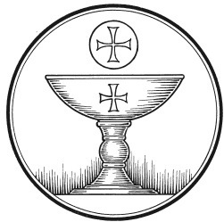
The Service of the Sacrament
This greeting marks a new service, so to speak. These ancient introductory words & phrases help to highlight, celebrate and bring attention to the Sacrament.
M: The Lord be with you.
C: And also with you.
M: Lift up your hearts.
C: We lift them up to the Lord.
M: Let us give thanks to the Lord our God.
C: It is good and right so to do.
M: It is truly good and right that we should at all times and in all places give you thanks, O Lord, holy Father, almighty and everlasting God, through Jesus Christ, our Lord, who promised that wherever two or three come together in his name, there he is with them to shepherd his flock till he comes again in glory. Therefore with all the saints on earth and hosts of heaven, we praise your holy name and join their glorious song:

HOLY, HOLY, HOLY – Sanctus
C: Holy, holy, holy Lord God of heavenly hosts:
heav’n and earth are full of your glory.
Hosanna, hosanna, hosanna in the highest!
Blessed is he, blessed is he, blessed is he who comes in the name of the Lord.
Hosanna, hosanna, hosanna in the highest.
WORDS OF INSTITUTION Matthew 26, Mark 14, Luke 22
M: Our Lord Jesus Christ, on the night he was betrayed, took bread; and when he had given thanks, he broke it and gave it to his disciples, saying: “Take and eat. This is my ✙ body, which is given for you. Do this in remembrance of me.”
The Words of institution both proclaim the words of Jesus to the congregation and sets apart the bread and wine for the Lord’s Supper.
Then he took the cup, gave thanks, and gave it to them, saying, “Drink from it all of you; this is my ✙ blood of the new covenant, which is poured out for you for the forgiveness of sins. Do this, whenever you drink it, in remembrance of me.”

PEACE OF THE LORD – Pax Domini John 20:19
M: The peace of the Lord be with you always.
C: Amen

O CHRIST, LAMB OF GOD – Agnus Dei John 1:29
C: O Christ, Lamb of God,
you take away the sin of the world;
have mercy on us.
O Christ, Lamb of God,
you take away the sin of the world;
have mercy on us.
O Christ, Lamb of God,
you take away the sin of the world;
Grant us your peace. Amen.

DISTRIBUTION
Those who will be receiving Holy Communion today may wish to read Personal Preparation for Holy Communion, found on page 156 in the front section of the hymnal. This page helps us put into practice what the Bible encourages: “Everyone ought to examine themselves before they eat of the bread and drink from the cup.” (1 Corinthians 11:28)
Christ Lutheran Church confesses and practices the Biblical teaching of a Closed Communion. We ask that only members of the Wisconsin Synod [WELS] or the Evangelical Lutheran Synod [ELS] join us at the Lord’s Table. If you have questions concerning our communion practice, or would like to inquire about how you, too, can commune with us, please speak with the Pastor following the service.
THE SONG OF SIMEON
C: Lord, now you let your servant, depart in peace
According to your word.
For my eyes have seen your salvation,
Which you have prepared before the face of all people,
A light to lighten the Gentiles
And the glory of your people Israel.

M: We give thanks, almighty God, that you have refreshed us with this holy supper. We pray that through it you will strengthen our faith in you and increase our love for one another. We ask this in the name of Jesus Christ, our Lord, who lives and reigns with you and the Holy Spirit, one God, now and forever.
C: Amen.

THE BLESSING
M: The Lord bless you and keep you.
The Lord make his face shine on you and be gracious to you.
The Lord look on you with favor and ✙ give you peace.
C: Amen.
CLOSING HYMN Redeemed, Restored Forgiven | CW 388

COPYRIGHT INFORMATION
Content requiring a copyright license is reproduced under OneLicense.net #A-718312. All rights reserved. The Common Service: Texts revised from The Lutheran Hymnal, 1941. Music revised by James Engel. Scripture Quotations: From the Holy Bible, New International Version (NIV 1984), © 1973, 1978, 1984 by Biblica, Inc.

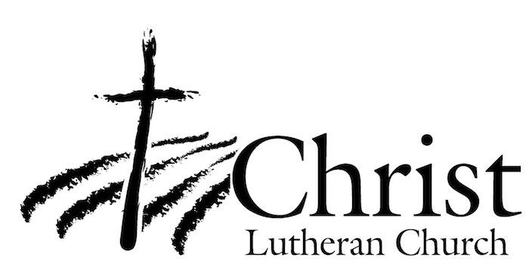
13009 N. Elderberry Ct.
Lodi, CA 95242
www.christlodi.org
209-368-6250
Pastor Timothy Leistekow
WELCOME TO CHRIST EV. LUTHERAN CHURCH!
We preach a message of forgiveness, hope and peace
through the death and resurrection of Jesus Christ.
Families and individuals of all ages will find opportunities
both to grow and to serve.
Our mission statement:
Look what Christ is doing!
He binds us together in fellowship
He gathers us in for worship
He builds us up for service
He sends us out with the gospel

“Now you are the body of Christ,
and each one of you is a part of it.”
(1 Corinthians 12:27)

